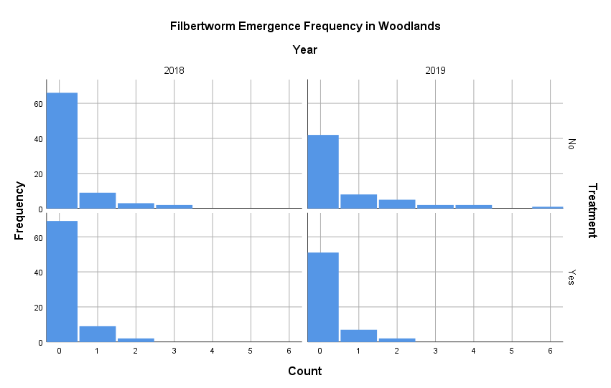

|  |  |  |  |  |  |
| --- | --- | --- | --- | --- | --- |
| **Tests of Between-Subjects Effects** | | | | | |
| Dependent Variable: Count | | | | | |
| Source | Type III Sum of Squares | df | Mean Square | F | Sig. |
| Corrected Model | 7.005a | 2 | 3.502 | 6.325 | .002 |
| Intercept | 2.626 | 1 | 2.626 | 4.742 | .030 |
| Year | 2.630 | 1 | 2.630 | 4.749 | .030 |
| Treatment | 4.375 | 1 | 4.375 | 7.901 | .005 |
| Error | 153.392 | 277 | .554 |  |  |
| Total | 185.000 | 280 |  |  |  |
| Corrected Total | 160.396 | 279 |  |  |  |

|  |
| --- |
| a. R Squared = .044 (Adjusted R Squared = .037) |

